ASSIGNMENT 1 FRONT SHEET

|  |  |  |  |
| --- | --- | --- | --- |
| **Qualification** | **TEC Level 5 HND Diploma in Computing** | | |
| **Unit number and title** | **Unit 04: Project Management** | | |
| **Submission date** |  | **Date Received 1st submission** |  |
| **Re-submission Date** |  | **Date Received 2nd submission** |  |
| **Student Name** | Chu Khải Lương | **Student ID** | BHAF200108 |
| **Class** | PBIT17103 | **Assessor name** | Ngô Thái Cường |
| **Student declaration**  I certify that the assignment submission is entirely my own work and I fully understand the consequences of plagiarism. I understand that making a false declaration is a form of malpractice. | | | |
|  | | **Student’s signature** |  |

**Grading grid**

|  |  |  |
| --- | --- | --- |
| P1 | M1 | D1 |
|  |  |  |

|  |  |  |
| --- | --- | --- |
| **Summative Feedback: ** **Resubmission Feedback:** | | |
| **Grade:** | **Assessor Signature:** | **Date:** |
| **Signature & Date:** | | |

# TABLE OF CONTENTS

1. **INTRODUCTION**
2. **CONTENT.**
   1. (P1) Initialize the project.
   2. (P2) Project management plan.
   3. (P3) Planning.
   4. (P4) Conduct small-scale research by applying appropriate quantitative research methods to meet the project's goals and objectives.

* Primary research.
* Secondary research.

1. **CONCLUSION.**
2. **REFERENCE LIST.**

## INTRODUCTION

Today, due to people's increasingly busy work and no time to take care of our health, sometimes we really want to improve our health but don't know where to start and where our body is. What condition, lack of information about your own health indicators, that's why we provide the product is the samsung gear fit 2 smart bracelet with the function of measuring health and physical indicators, heart rate, sleep monitoring to record the measured data, store information and from there make recommendations for exercise schedules to promote better health.

1. **CONTENT.**
2. **Initializing the project. (P1)**

Project objective: smart bracelet samsung gear fit 2

* 1. Main objectives to be accomplished.

-Complete smart bracelet from April 1, 2022-May 31, 2022

+ Smart bracelet touch screen design (time: 15 days)

+ smart bracelet design (duration: 15 days)

+ research and buy chips and install on smart bracelets (duration 20 days)

+ Successfully installed smart bracelet (time 11 days)

## Project management plan. (P2)

* 1. **Scope**

The project has almost completed all the targets set out:

+ Smart bracelet touch screen design (time: 15 days)

+ smart bracelet design (duration: 15 days)

+ research and buy chips and install on smart bracelets (duration 20 days)

+ Successfully installed smart bracelet (time 11 days)

* 1. **Time.**

Total project time is 61 days

* 1. **Communicate.**

|  |  |  |
| --- | --- | --- |
| 1 | Communication content. | Exchange method. |
|  | Project management staff  meeting. | Company meeting room |
|  | Meeting to divide projects within the scope of the company,communicate  through chat channels | Company meeting room |

* 1. **Risk**

|  |  |
| --- | --- |
| Risk name | Ability |
| Lack of funds | Normal |
| Risks in the design, purchase of equipment | Normal |
| Device risk | high |
| Technical and operational  risks | High |
| Short battery life | Normal |

* 1. **Resources.**
     1. • 3 project manager.
     2. • 2 Technical Director.
     3. • 7 software engineers.
     4. • 3 employees testing the product.
     5. • 3 error correction calculators.
     6. **Project cost.**

|  |  |  |  |
| --- | --- | --- | --- |
|  | **Expenses.** | **Amount** | **Amount of money** |
| **1** | Project Manager | 3 | 6.000 USD |
| **2** | Technical director | 2 | 4.000 USD |
| **3** | software engineer. | 7 | 3.000 USD |
| **4** | Product testers. | 3 | 1.500 USD |
| **5** | Change. | 4 | 8.000 USD |
|  | **Total cost.** | **9** | **22.500 USD** |

1. **Planning. (P3) 1.WBS**

* Define :

wbs is a work, a technique and work breakdown structure (wbs) can bring to project managers, participating members many advantages and it is one of the project managers. The most important project wbs has the additional feature that it can be divided into several separate tiers. However, these tiers do not bring the main effect, in each of these tiers, only specific summary reports will be selected.

### Project WBS:

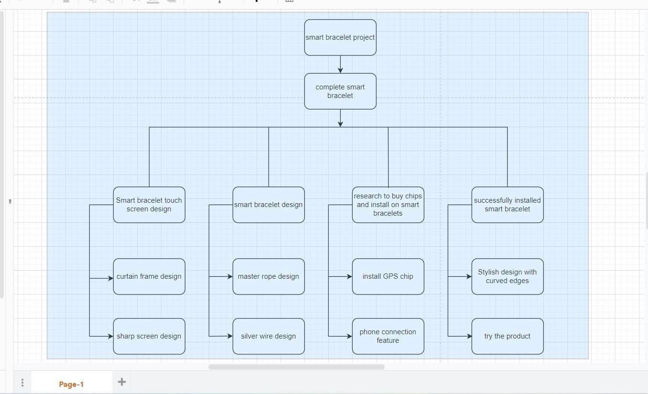

* + - 1. **Gantt chart.**
* **Define:**

Gantt chart is one of the oldest tools that is still commonly used in project schedule management. gantt chart has roles such as milestone chart, activity chart, project bar chart ... depending on the needs of the project manager. Project management for gantt chart is easier because looking at the chart can calculate the time and the management organization will become more accurate and guaranteed.

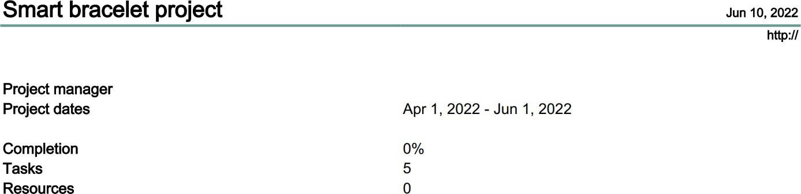

Smart braulet project Tasks

Jun 10, 2022

2

|  |  |  |
| --- | --- | --- |
| Name | Begin date | End date |
| complete smart bracelet | 4/1/22 | 5/31/22 |
| Smart bracelet touch screen design | 4/1/22 | 4/15/22 |
| smart bracelet design | 4/16/22 | 4/30/22 |
| research to buy chips and install on smart bracelets | 5/1/22 | 5/20/22 |
| successfully installed smart bracelet | 5/21/22 | 5/31/22 |

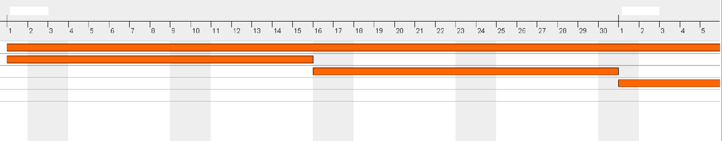

April 2022

May 2022

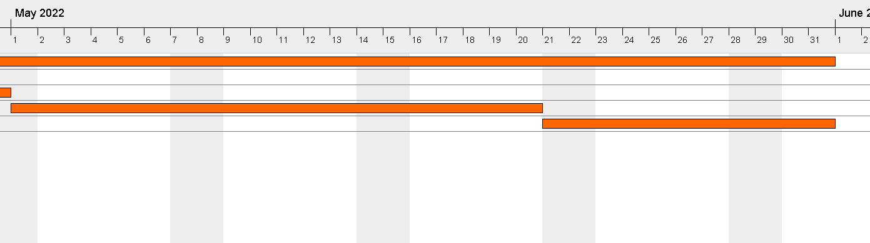



### Research (P4)

* + - * 1. **Preliminary research:**
  + In order to bring credibility and good product quality, here is an overview of the survey with customers about the functions of the smart bracelet in our company.

### List of interview questions

* + Have you ever used our products?
  + In your opinion, how is the service and advice attitude of the staff?
  + How do you think the price of your product is?
  + Do you have any problems in the process of buying - receiving the product?
  + Do you like the design and decoration of this bracelet?
  + Are the functions on this smart bracelet good?
  + Does the smart bracelet need to add or remove any functions?

### Summary of the interview

* + Hello friend, here I will ask you a few things about the smart bracelet, have you used this product is it good or not and when you use this product what do you see on the bracelet? what does this ring give you when you don't have it

### List of survey questions

* + Do you have a smart bracelet yet?
  + What do you think if you have a smart bracelet?
  + Currently we are working on a smart bracelet project with many special features. Do you want this project to be born?

### Summary of the survey

* + Hello, here I will summarize the survey of a smart bracelet as a compact accessory that supports many modern features and comes at a much cheaper price than a SmartWatch. Smart bracelet supports modern features such as heart rate monitoring, exercise mode, health index measurement, frequent hand washing reminder...and many other interesting features.

### Evaluation of interviews and surveys

* + Company staff always listen and understand your needs client.
  + The company cares about customers anytime, anywhere.
  + The company always respects the interests of customers
  + The company always cares about the opinions of its customers.
  + Company employees create trust for customers.
  + Staff are always welcoming to customers
  + Staff are ready to help anytime, anywhere.

### Secondary research

**-Define:**

Secondary research is the collection of information from pre-existing sources, conducted by government organisations, chambers of commerce, trade associations and other organisations, and is easily searchable for most information news is free or low cost.

[https://fptshop.com.vn/tin-tuc/danh-gia/danh-gia-samsung-galaxy-fit-2-vong-deo-tay-thong-minh-ngon-](https://fptshop.com.vn/tin-tuc/danh-gia/danh-gia-samsung-galaxy-fit-2-vong-deo-tay-thong-minh-ngon-bo-re-129978#%3A~%3Atext%3DSamsung%20Galaxy%20Fit%202%20l%C3%A0%20m%E1%BB%99t%20v%C3%B2ng%20%C4%91eo%20tay%20th%C3%B4ng%2Cth%E1%BB%9Di%20l%C6%B0%E1%BB%A3ng%20pin%20xu%E1%BA%A5t%20s%E1%BA%AFc) [bo-re-](https://fptshop.com.vn/tin-tuc/danh-gia/danh-gia-samsung-galaxy-fit-2-vong-deo-tay-thong-minh-ngon-bo-re-129978#%3A~%3Atext%3DSamsung%20Galaxy%20Fit%202%20l%C3%A0%20m%E1%BB%99t%20v%C3%B2ng%20%C4%91eo%20tay%20th%C3%B4ng%2Cth%E1%BB%9Di%20l%C6%B0%E1%BB%A3ng%20pin%20xu%E1%BA%A5t%20s%E1%BA%AFc) [129978#:~:text=Samsung%20Galaxy%20Fit%202%20l%C3%A0%20m%E1%BB%99t%20v%C3%B2n](https://fptshop.com.vn/tin-tuc/danh-gia/danh-gia-samsung-galaxy-fit-2-vong-deo-tay-thong-minh-ngon-bo-re-129978#%3A~%3Atext%3DSamsung%20Galaxy%20Fit%202%20l%C3%A0%20m%E1%BB%99t%20v%C3%B2ng%20%C4%91eo%20tay%20th%C3%B4ng%2Cth%E1%BB%9Di%20l%C6%B0%E1%BB%A3ng%20pin%20xu%E1%BA%A5t%20s%E1%BA%AFc) [g%20%C4%91eo%20tay%20th%C3%B4ng,th%E1%BB%9Di%20l%C6%B0%E1%BB%A3ng%20pin](https://fptshop.com.vn/tin-tuc/danh-gia/danh-gia-samsung-galaxy-fit-2-vong-deo-tay-thong-minh-ngon-bo-re-129978#%3A~%3Atext%3DSamsung%20Galaxy%20Fit%202%20l%C3%A0%20m%E1%BB%99t%20v%C3%B2ng%20%C4%91eo%20tay%20th%C3%B4ng%2Cth%E1%BB%9Di%20l%C6%B0%E1%BB%A3ng%20pin%20xu%E1%BA%A5t%20s%E1%BA%AFc)

[%20xu%E1%BA%A5t%20s%E1%BA%AFc](https://fptshop.com.vn/tin-tuc/danh-gia/danh-gia-samsung-galaxy-fit-2-vong-deo-tay-thong-minh-ngon-bo-re-129978#%3A~%3Atext%3DSamsung%20Galaxy%20Fit%202%20l%C3%A0%20m%E1%BB%99t%20v%C3%B2ng%20%C4%91eo%20tay%20th%C3%B4ng%2Cth%E1%BB%9Di%20l%C6%B0%E1%BB%A3ng%20pin%20xu%E1%BA%A5t%20s%E1%BA%AFc).

[https://tinhte.vn/thread/tren-tay-galaxy-fit2-vong-deo-thong-minh-nho-gon-bo-sung-nhieu-tinh-](https://tinhte.vn/thread/tren-tay-galaxy-fit2-vong-deo-thong-minh-nho-gon-bo-sung-nhieu-tinh-nang.3233483/) [nang.3233483/](https://tinhte.vn/thread/tren-tay-galaxy-fit2-vong-deo-thong-minh-nho-gon-bo-sung-nhieu-tinh-nang.3233483/)

<https://bloggiamgia.vn/danh-gia-samsung-galaxy-fit-2/>

**Assessment of understanding:**

To my knowledge, the Samsung Galaxy Fit2 smart bracelet helps us to support effective and scientific management of sports training, heart rate monitoring, exercise mode, physical health index measurement, on this bracelet do not know it has the same uses as above and do not understand whether it has the same good performance as the manufacturer has surveyed properly or not, I will take the time to really learn about this bracelet

**Conclusion.**

The above are the projects that I did about the samsung gear fit 2 smart bracelet bracelet with the function of measuring health, physical, heart rate, sleep monitoring to record measurement data. obtain, store information and from there make recommendations on a training schedule to promote better health and an indispensable bracelet in our lives.